**Experiment No. 9**

**Aim:** TCP/IP network administration**: ifconfig, ping, netstat, inetd, pppd, etc.**

1. **ifconfig command:**

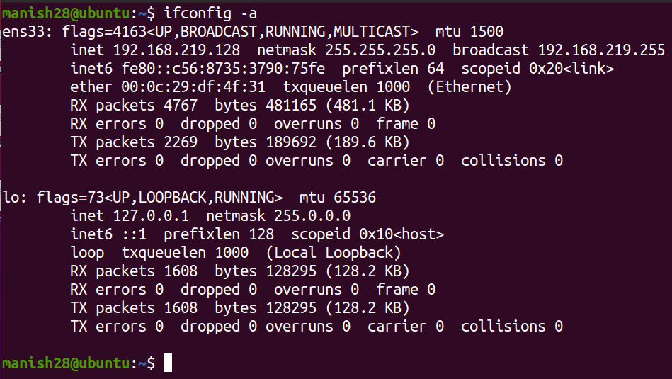

1. **ping command:**

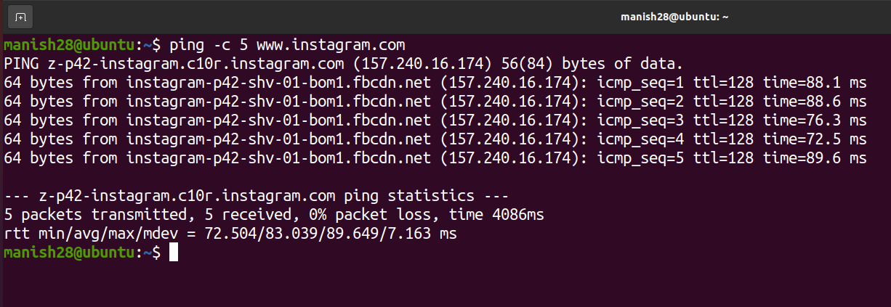

1. **netstat command (-au shows all udp connections):**

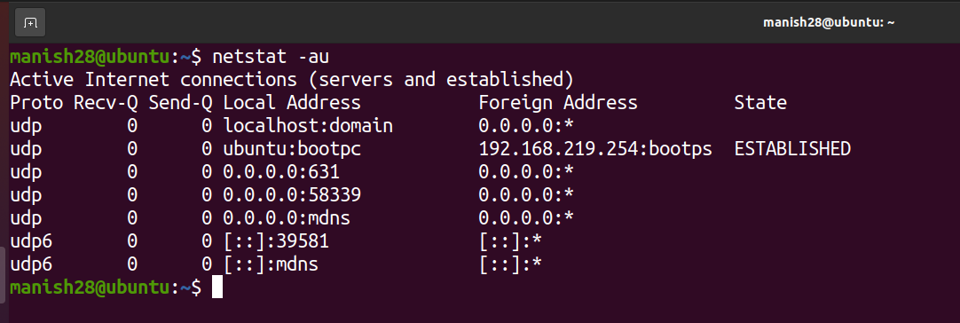

1. **inetd command:**

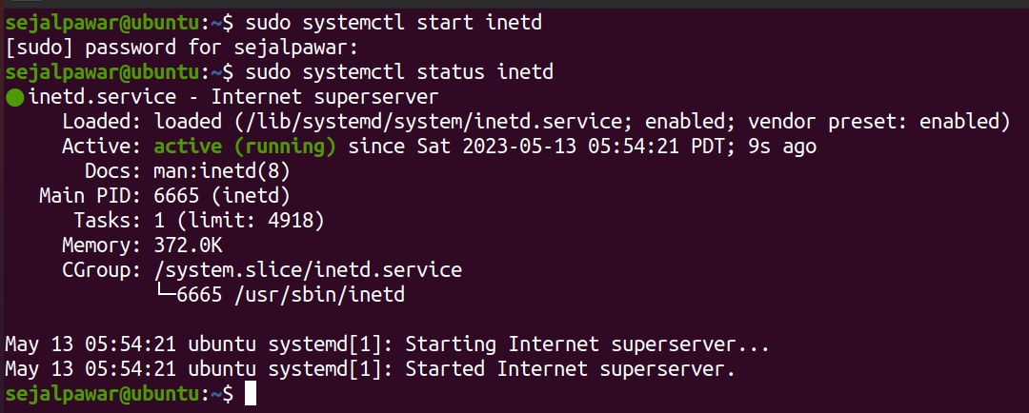

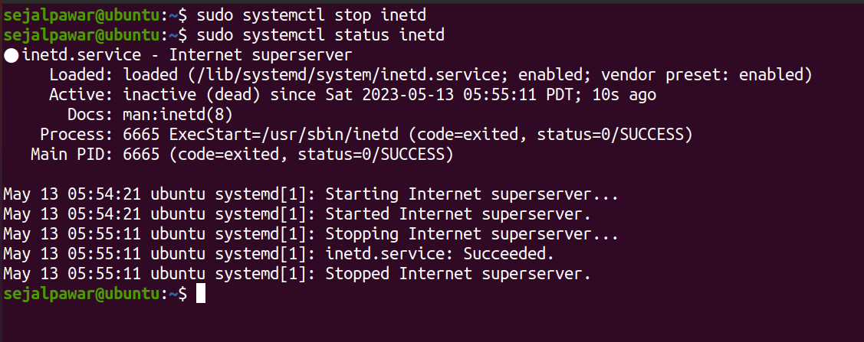

1. **pppd command:**

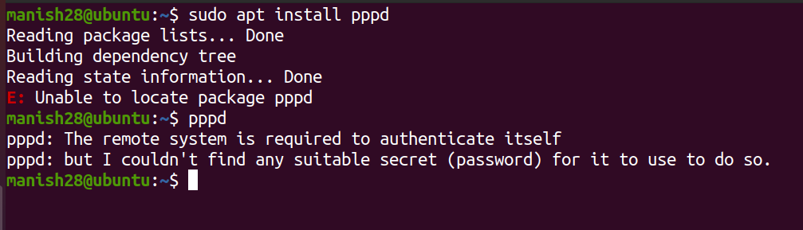

|  |  |  |  |
| --- | --- | --- | --- |
| **Practical Performance**  **(4)** | **Writeup & Oral**  **(4)** | **Attendance**  **(2)** | **Total**  **(10)** |
|  |  |  |  |